Lab sheet - 0 7 CIS 31042- Practical for Data Mining

Reg No :SEU-IS-19-ICT-003

Topic: Partitioning Clustering Algorithm

Aim: Working with K-Mean Algorithm

Task: Apply the K-Mean technique to real world data set

Exercise:

- Load the Bank.arff data set into Weka (Use the output dataset of lab sheet 03)

- Explaining the clusterer interface

- Set the cluster mode to training set

- Cluster the data set

- Interpret the output

- Change the seed value as 8

- Interpret the output

- Store cluster visualization or visualize cluster assignment

- Set the classes to evaluate the clusters as age and interpret the output

- Change the evaluator attribute as PEP

- Load the Bank.arff data set into Weka (Use the output dataset of lab sheet 03)

- Open weka Click on explorer Clcik on “open file” and browns the bank.arff out put dataset file of previous practical session and open

- Explaining the clusterer interface
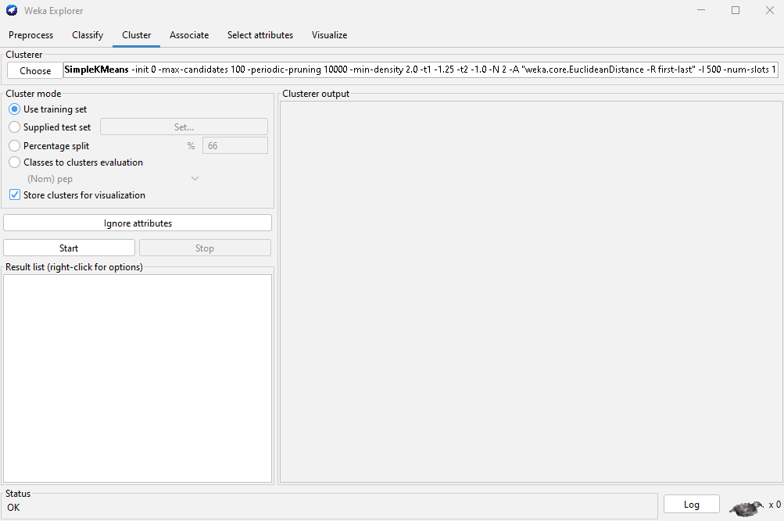

- When considering the cluster interface, it gave to select various clusters. we can perform clustering task selecting relent clustering technique

Under the cluster mode there is an options “Use training set,” “Supplied test set,” “Percentage split,” and “Classes to clusters evaluation.”

- Use Training Set: Clustering using the entire training dataset.
- Supplied Test Set: Evaluating model performance on separate test data.
- Percentage Split: Balancing training and validation data.
- Classes to Clusters Evaluation: Assessing how well clusters align with known classes.

- Set the cluster mode to training set

- In the cluster interface there is option called cluster modeunder the cluster mode there is “use training set option Select that option

- Cluster the data set

- First choose the cluster as “simpleKMean” set percentage split as 66% Click on chosen “simpleKMean” then simpleKMean settings panel open change the “numCluster” as 2 and seed as 10
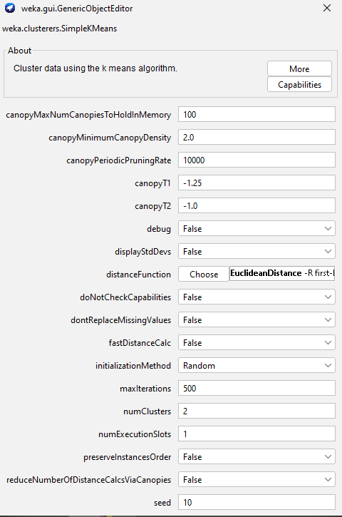

- Interpret the output
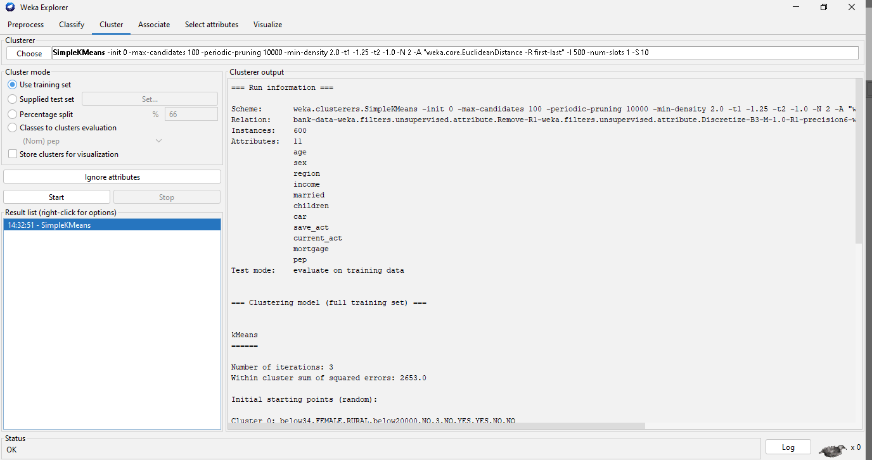

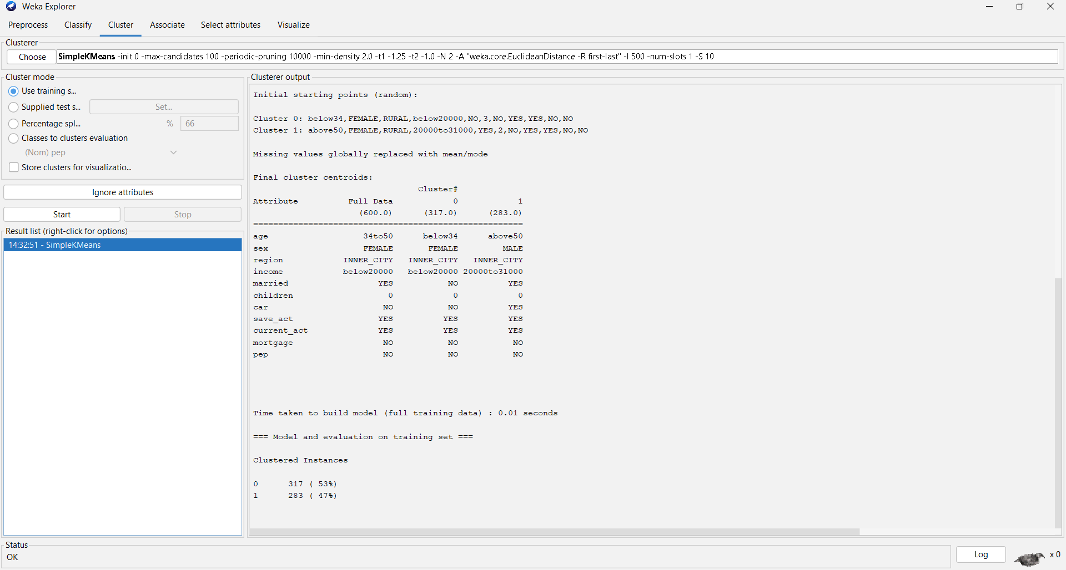

- According the output this kMenas algorithm iterate 3 times for preform the clustering and we gave command to generate the two clusters base on that using this kMean algorithm it generates two clusters which are

- All instance in the data set is 600 but among those 317 (53%) instance are belongs to cluster 1 and 283(47%) instances are belongs to cluster 2.

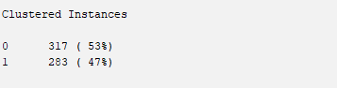

- Change the seed value as 8
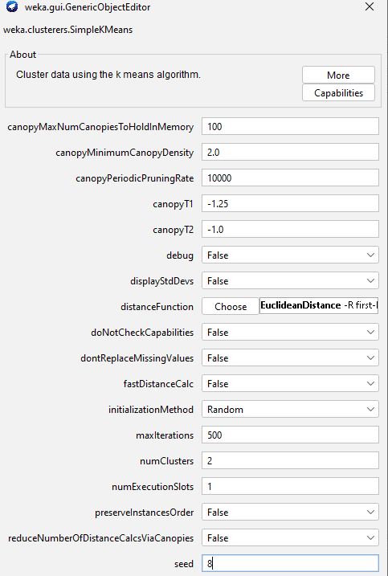

- Interpret the output
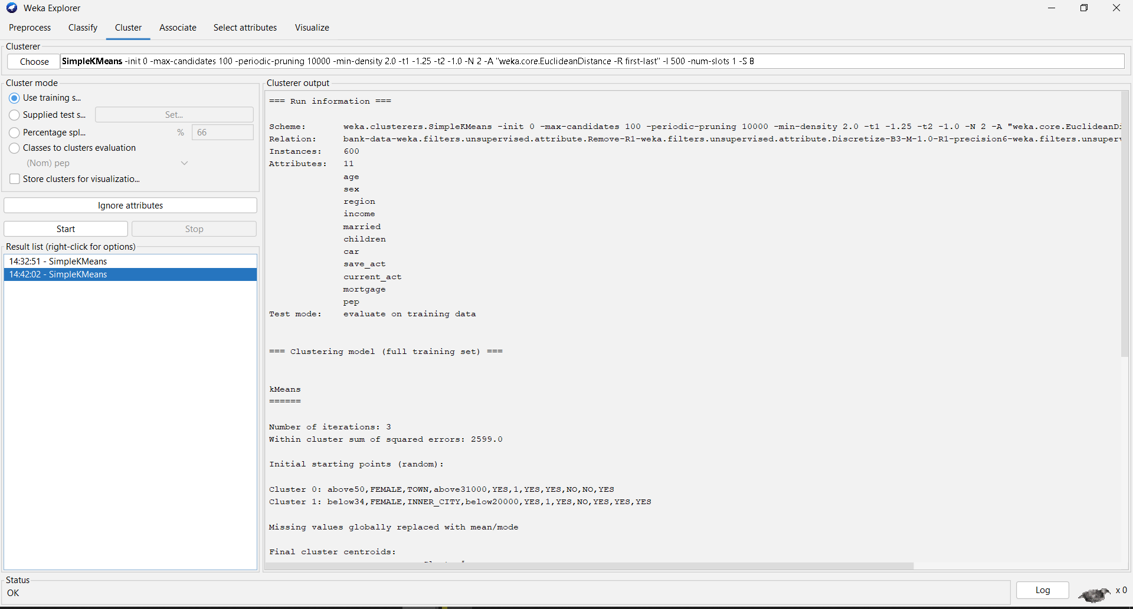

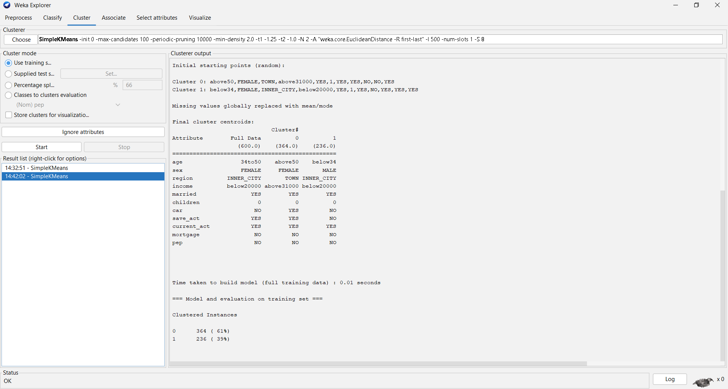

- According the output this kMenas algorithm iterate 3 times for preform the clustering and we gave command to generate the two clusters base on that using this kMean algorithm it generates two clusters which are

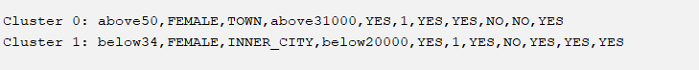

- All instance in the data set is 600 but among those 364 (61%) instance are belongs to cluster 1 and 236(39%) instances are belongs to cluster 2.

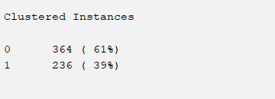

- Store cluster visualization or visualize cluster assignment

Result list Select one result which you want visualize right click on it Select visualize cluster assignment

- Set the classes to evaluate the clusters as age and interpret the output
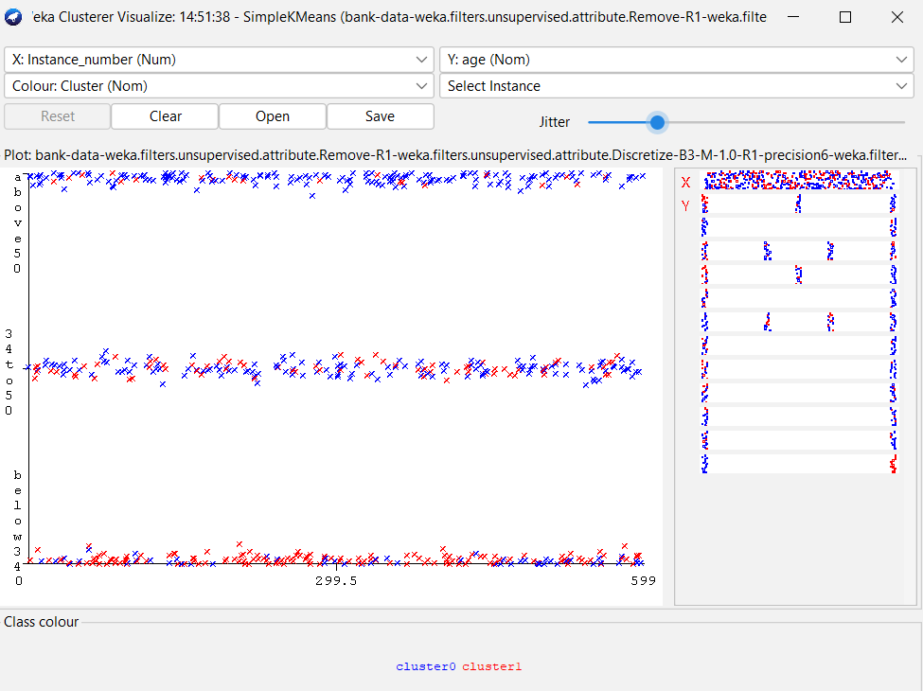

- Above chart shows the how instances are split base on the age among cluster one and cluster two. X axis shows the number of instance and y axis shows the range of the age.
- Cluster one represents through the blue color and cluster two represent through the red color. When considering the age below 34 most of them are belongs to cluster two but when we consider the age between 34 to 50 most them are belongs to cluster 1. In the age range above 50 also we can see most them are belong to cluster 1

- Change the evaluator attribute as PEP
- Within the cluster mode select the mode as classes to cluster evaluationwithin the drop-down list select attribute as PEP
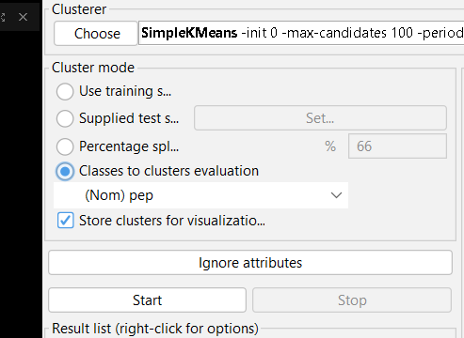

Discussion

- We used the K-Means clustering method on a real-world dataset in this lab. K-Means is a good way to put data points into groups based on how alike they are. We talked about exploring datasets, preprocessing them, and choosing the best number of groups (K). Using K-Means helped us understand the grouping results and rate their quality using measures such as the sum of squares within each cluster. Visualizations helped us understand how the groups were put together. Overall, this hands-on lesson taught me how to use K-Means to find patterns in data, which was very helpful.

